Truro & District Motor Club

Foreword

The Club would like to welcome you to Tregrehan Speed Hillclimb 2024 held in the magnificent parkland of Tregrehan Estate Gardens near St Austell PL24 2SJ.

The 2024 Truro Speed Academy is pleased once again to welcome on board Camel Vale Motor Club. They will be hosting events that count towards the 2024 Truro Speed Academy, we thank them for their efforts and assistance.

The four speed Hillclimb’s at Tregrehan over two weekends, will form part of the 2024 Fusion Fostering ASWMC Hillclimb Championship and the 2024 Cornwall Speed Championship. Also, this year, we are running our own Club Speed Championship, kindly sponsored by Richards Bros.
Saturday 15th & Sunday 16th June will also form part of the National Motor Cycle Speed Hillclimb Championship and the Club look forward to welcoming the many motorcycle competitors from all over the country.

Please Note: In order to reduce noise levels, the Club will allow tyre warming in the designated area prior to the start line, but we are requesting that competitors keep this to a minimum of once per run.

For further information please check out:
www.trurodmc.co.uk

For details about the Tregrehan Estate and self-catering cottages please visit:
www.tregrehan.org

This year the club are delighted to be supporting Westcountry Rescue and MS Society South West

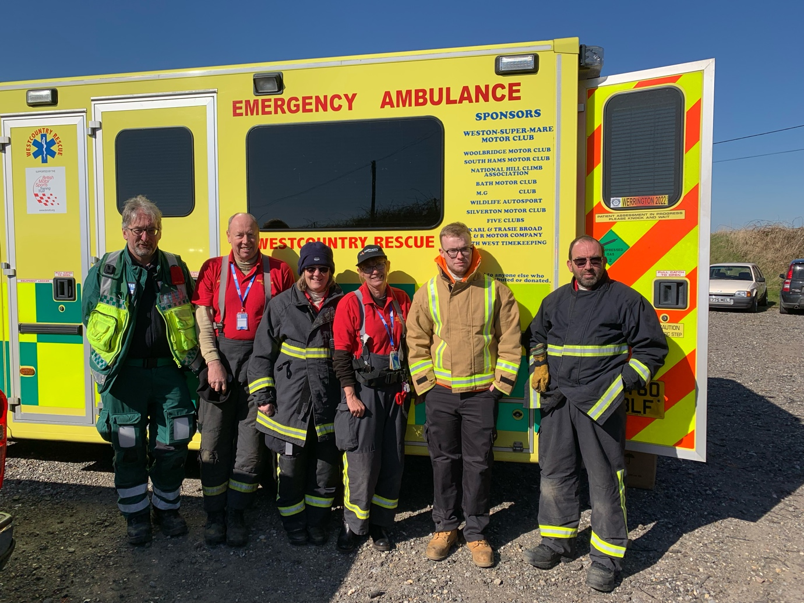

Westcountry Rescue

We are a limited company providing rescue units to motorsport events throughout the southwest and occasionally further afield, including sprints, hillclimbs, rallies, autocross, 4x4, trials and motorbike hillclimb’s
The crew are all volunteers with training in extrication, fire, and extended first aid,
we work alongside the doctor or paramedic at any incident during the motorsport event.
We also provide first aid for spectator events and have a dedicated first aid ambulance.

We pride ourselves in being available to help in any capacity often marshalling a post, and generally being helpful and friendly to the event officials and competitors alike.

We are always looking for more volunteers to join the rescue and first aid teams, you need to be flexible and attend training events and most importantly to enjoy a variety of motorsport

Contact Glyn Davies 07591 921604, John Sluman 01752 340146 for more information

Multiple sclerosis (MS) is a condition that affects your brain and spinal cord. In MS, the coating that protects your nerves (myelin) is damaged. This causes a range of symptoms like blurred vision and problems with how we move think and feel.
Once diagnosed, MS stays with you for life, but treatments and specialists can help you to manage the condition and its symptoms.
More than 130,000 people in the UK have MS. In the UK people are most likely to find out they have MS in their thirties, forties and fifties. But the first signs of MS often start years earlier. Many people notice their first symptoms years before they get their diagnosis.
MS affects almost three times as many women as men. People from many different ethnic backgrounds can get MS. Read the latest statistics on MS in the UK.

What happens in MS?
To understand what happens in multiple sclerosis, it's useful to understand how the central nervous system works.
A substance called myelin protects the nerve fibres in the central nervous system, which helps messages travel quickly and smoothly between the brain and the rest of the body.
In MS, your immune system, which normally helps to fight off infections, mistakes myelin for a foreign body and attacks it. This damages the myelin and strips it off the nerve fibres, either slightly or completely, leaving scars known as lesions or plaques.
This damage disrupts messages travelling along nerve fibres – they can slow down, become distorted, or not get through at all.
As well as losing the myelin, there can sometimes be damage to the actual nerve fibres too. It's this nerve damage that causes the increase in disability that can occur over time.

What causes MS symptoms?
The central nervous system links everything your body does, so multiple sclerosis can cause many different types of symptoms. The specific symptoms that appear depend on which part of your central nervous system has been affected, and the job of the damaged nerve
Call the MS Society 0808 800 8000
Truro & District Motor Club Ltd
SUPPLEMENTARY REGULATIONS
Saturday 15th & Sunday 16th June 2024
Saturday 5th & Sunday 6th October 2024

- The Truro & District Motor Club will organise Interclub Hillclimb’s on the weekends of the 15th & 16th June and 5th & 6th Oct at Tregrehan Gardens Nr St. Austell. Cornwall PL24 2SJ.

- The Meetings will be held under the General Regulations of the Motorsport UK (incorporating the provisions of the International Sporting code of the FIA), these Supplementary Regulations and any written instructions the promoting club may issue for the event.

- Motorsport UK Permit Numbers 15th & 16th June 2024 TBA
5th & 6th October 2024 TBA

- The events are open to all fully elected members of the promoting club and members of clubs belonging to the Association of South Western Motor Club (ASWMC), the Aston Martin Owners Club and the Vintage Sports Car Club. Club Membership Cards, Competition Licences and, where appropriate, Championship Registration Cards will be inspected at Signing On. Particular attention should be paid to Regulation S 7.1.5 with reference to the need for a National A (Open) licence for certain cars over 2000cc or 1428 cc if forced induction.
- 2024 Fusion Fostering ASWMC Hill Climb Championship – Motorsport UK Permit No. CH2024 / S086 (E)
- Cornwall Speed Championship – Motorsport UK Permit No. TBA
- Richards Bros Truro & District Motor Club Speed Championship – Motorsport UK Permit No. TBA
- Torbay Speed Championship – Motorsport UK Permit No: TBA

- The length of the course is approximately 500 yards and consists of a tree lined avenue and three corners of varying degree.
- Attention is drawn to the requirement for a Motorsport UK Passport as defined by Regulation S. 9.1.7.

- Provisional results will be published as soon as possible after the completion of timed runs. Appeals should be made within 30 minutes of publication of provisional results, in accordance with Regulation C. 6.3(f).

- Competitors will be permitted to walk the course and are strongly encouraged to do so but must be clear of the hill by 08:30 on each day.

- Cars will start singly in their own time after the green light is displayed. The method of timing will be electronic by the breaking of beams at the Start and Finish lines. The finish line will be indicated by a white line and banner. Timing Struts in accordance with Regulation S.10.9 must be fitted.

- Competitors will have one practice run S2.1.1, S9. Immediately following practice three competitive timed runs will commence, additional timed runs will be taken if time permits. All timed runs will count for awards. For the Sunday event, competitors who competed on the previous day may if they wish not take any practice runs.

- Competitors are responsible for providing their own competition numbers as Regulation S. 9.2.5. Drivers of shared cars must ensure the appropriate number is displayed for each run.

- Competitors' attention is drawn to the requirements of Regulation S. 9.2.1. Throughout practice and competition, upon exiting from and until returning to the Paddock, when the driver is seated in the vehicle, he must wear clothing, helmet and goggles complying with K.9 to 11 or, where appropriate the specific Class regulations. Overalls homologated to either FIA 8856-2000 or FIA 8856/2018 or FIA 1986 standard are mandatory with the exception of Standard Cars (11) where flame resistant clothing is recommended (arms and legs must be covered) and road cars (12) where overalls must comply with K9.1.4. Competitors are required to wear flame-resistant gloves (K.14.3)), with the exception of standard cars (11) and road cars (12).
S9.2.1.3An FIA approved FHR device, fitted in accordance with FIA regulations is mandatory for all drivers with the exception of Period Defined Vehicles, standard cars (11), Road cars (12). All these items must be produced for inspection and approval at scrutineering.

- Competitors running their car on Non-pump fuel must indicate this on the Entry Form, and must display a 3-inch diameter “DayGlo” orange disc on a contrasting background affixed adjacent to their competition number on both sides. It also has to have an approved additive S10.6.2 (A) Competitors should comply with Regulation S10.6.2

- The use of any external device or power source to preheat the tyres of a competing car, whether the tyres are fitted to the car or not, is prohibited.

- Competitors are informed that some information from the Entry Form for these events will be stored in a computer system by the Secretary of the Meeting for the use of Truro & District Motor Club in the administration of Speed events.

- The programme of the Meetings will be as follows:
  - Signing-on will start at approximately 07.30 and all competitors must be signed on by 08.30.
  - Scrutineering will start at approximately 07.30 and will be conducted in your allocated . Paddock space.
  - All competitors must attend the drivers briefing at 08.45.
  - Practice will start at approximately 09.00.
  - The first competitive runs will follow on after practice is completed.

- Any competitor who, because of distance or other genuine reason, finds difficulty in complying with the times above may report at a different time provided that prior permission has been obtained from the Secretary of the Meeting.

1. Classes are as follows:
A0: Junior Driver competing in Standard Cars up to 1400cc
A1. Road Cars Series production up to 1400cc
A2. Road Cars Series Production over 1400cc up to 1800cc
A3. Road Cars Series Production over 1800cc up to 2600cc
A4. Road Cars Series Production over 2600cc
B1. Road Cars Specialist Production. Car engines up to 1400cc
B2. Road Cars Specialist Production. Car engines over 1400cc up to 1800cc
B3. Road Cars Specialist Production. Car engines over 1800cc & M/C engines
C1. Modified Cars Series Production up to 1400cc
C2. Modified Cars Series Production over 1400cc up to 1800cc
C3. Modified Cars Series Production over 1800cc
C4. Modified Cars Specialist Production. Car engines & M/C engines
D1. Sports Libre Cars up to 1800cc
D2. Sports Libre Cars over 1800cc
D3. Rally Cars
E1. Racing Cars up to 1100cc
E2. Racing Cars over 1100cc up to 1600cc
E3. Racing Cars over 1600cc up to 2000cc
E4. Racing Cars over 2000cc
Class V1 Historic Cars
Class V2 Vintage Cars

Standard Cars in accordance with S11.9.1

Note 1:
All cars must comply with S.10.1-10.9.

Note 2:
Series Production Cars are defined as cars complying with S.12.1.1 to S.12.7.5
Specialist Production Cars are defined as cars complying with S.12.1.2 to S..8.1
Modified Series Production Cars are defined as cars complying with S.13.1 to S.13.9
Modified Specialist Production Cars are defined as cars complying with S.13.2 to S.13.9
Sports Libre Cars must comply with S.14 and Racing cars with S.15.
Rally Cars must comply with R.46-49 AND S.14. Included in the latter Category would be Group B cars, any cars without the original engine block of the model entered, and car with a transmission layout not as originally specified for that model, or a Specialist Rally Car without an engine complying with S.13.6.2. They need not be taxed.
Note 3: The onus of responsibility for the eligibility of vehicles competing in the championship rests with the Entrant/Competitor. In the event of a dispute concerning the compliance of a vehicle to the regulations, the onus will be on the competitor to satisfy the organisers, NOT the organisers to prove compliance.
Note 4: Double drive (second) competitors will be identified by the letter ‘A’ alongside the vehicle event number. Academy entrants will be identified by the letter ‘T’ alongside their numbers.
Note 5: A0 Junior Class must comply with S7.1.9 – 7.1.9.2 and S10.2.9 and S11. Section K2.1.2.
Junior drivers must be identified by the letter ‘J’ alongside the vehicle event number.

All vehicles must comply with Motorsport UK Regulations as appropriate.
In addition, particular notice should be taken of Section S in the 2024 Motorsport UK Yearbook.

- Awards for each event will be presented as follows:
- FTD – A Major Cup and replica (the major cup will be held for 11 months only).
- 1st in each Class - An Award (subject to 3 starters)
- 2nd in each Class - An Award (subject to 5 starters)
- 3rd in each Class - An Award (subject to 8 starters)

Competitors may only win one award in each class.

All trophies will be given out at Truro & District Motor Club’s annual awards presentation.

- Entries
The maximum entry for each day is 80. The minimum for each event is 40 and 3 for each class. Should any of the minimum figures not be reached, the organisers have the right to amalgamate the classes or cancel the event. No car may be entered in more than one class. No car may be shared by more than two drivers.

- The entry lists open upon publication of these regulations and closes on Sunday 9th June for the June events & Sunday 29th September for the October event. The entry fee for 2024, is £75.00 per day. Acknowledgement of your entry will be given after online entry form is completed. Final instructions and results will be provided electronically. The organisers do not accept liability for non-receipt of emails.

- Entries Secretary:
Amanda Moo. 19 Higher Penponds Road, Higher Penponds Camborne. TR14 0QG. Email; mandamoo@trurodmc.co.uk
Tel 07877 294632

- Entry fees will only be refunded as follows:
Notification of Withdrawal by the closing dates, Sunday 9th June & 29th Sept for the October event a Full refund. If notification of withdrawal is after that time, there will be an admin fee deducted
- Senior Officials of the Meeting:

Note- please do not ring officials outside 5.00pm to 9.00pm

Motorsport UK Steward: TBC
Event Stewards: TBC
Clerk of the Course: Richard Weeks
Clerk of the Course: Jane Day
Event Secretary: Amanda Moo 07877294632
Entries Secretary: Amanda Moo - 07877294632
Chief Timekeeper: TBC
Chief Scrutineer: TBC
Assistant Scrutineer: TBC
Environmental Scrutineer: Geoff Gibson
Chief Medical Officer: Dr. Stuart Hateley
Rescue Unit: Westcountry Rescue
Chief Marshal: Darren Smith
Safeguarding Officer: Dr. Stuart Hateley
Paddock Marshal Roy Hartley

- Any protests must be lodged in accordance with Section C of the 2024 Yearbook.

- The starting order will be determined by class and numerical order. Cars will start singularly at intervals of approximately 30 secs. Competitors MUST be ready to take their run and to comply with the paddock marshal official’s instructions throughout the day or be prepared to forfeit their run. The batch running order will be ‘posted’ at the signing on office.

- The finish line will be identified by a Chequered Flag.

- Event insurance covering Third Party damage whilst on private land currently carries an excess of £450 per incident. The organising Club reserves the right to recover the cost of repair of any third-party damage, up to a maximum of £450 per incident, from the entrant of any vehicle which causes such damage.

- Truro & District Motor Club would like to draw competitor’s attention to the rules on the wearing of HANs devices in section K10 and K13 of the Motorsport UK Yearbook 2024.

- All other general regulations of Motorsport UK apply as written.

- Catering, water and toilets facilities will be available on site.

- Please ensure you stay within your designated Pit Area as directed on arrival.

- Truro & District Motor Club with the kind permission of Mr & Mrs Hudson will permit overnight camping for competitors in Tregrehan Paddock on the Friday and Saturday nights only, the cost will be £10.00 per tent, caravan or camper per night. There is water available.
Please note that the charge for camping is not a club decision, but a commercial one formulated by Tom & Jo Hudson. The club are though, charged with collecting the monies.
Camping permits will be issued on arrival for those who pay with their entry, at the signing on shed. All camping MUST be paid for, no later than when you sign on, on Saturday morning, when a permit will be issued.

